Magnifying Glass Microscope

Subject:  Related Subjects: | Grade Level(s):k,1,2,3,4,5,6,7,8  Length of Lesson: | Type: Inquiry / Design / Project  Keywords:Focal point, magnification, balance

Lesson Overview
Use this section to describe at a high level what the lesson is. Should be no more than 3-4 lines.

Lesson Focus
What is the central question or phenomenon being investigated? What problem are they trying to solve?

Lesson Objective(s) | - Students will build a microscope with a light  - Students will use microscope to observe objects

Lesson Timing

5 minutes | Introduce the Lesson
30 minutes | ...

Materials | - –Foam board  - –Xacto knife  - –Glue gun  - –Glue sticks  - –Magnifying glass (with hole on end of handle)  - –7” straw coffee stirrers  - –PVC pipe  - –PVC tees  - –Brass fasteners  - –Large paper clips  - –2-AA battery holder  - –AA batteries  - –Electric tape  - –Craft sticks  - –Rubber bands  - –Washers  - –Light bulb  - –Pencil  - –Drill and drill hole
Instructor Prep | - Step 1
Related Resources | - List related lessons/ppts etc available from USC or outside, trusted orgs

Lesson Plan

Introduction
Introduce students to the learning goals and make connections to past and present learning experiences. Stimulate interest and prompt students to identify their own questions about the topic. This can link the lesson to real world examples, introduce associated STEM careers, and assess their prior knowledge on the topic.

- Step 1

Procedure

- –Glue stirrer to back of top craft sticks on back of structure.
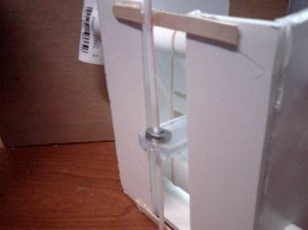
- –Use pencil to poke small hole 1” from bottom and 1” from top of structure
- –Insert bulb and glue in place with bulb pointing to ward bottom of structure
- –Make one slit on one side of structure
- –Make 2nd slit 1 ½” below first slit, but ½” to the right.
- –Insert red wire of battery holder between arms of fastener, insert through top slit and open fastener
- –Twist black wire of battery holder and a wire of bulb
- –Insert other wire of bulb into 2nd fastener.
- –Attach paperclip to second fastener
- –Insert fastener through bottom slit and open fastener. Paper clip will remain on outside of structure
- –Glue battery holder in place
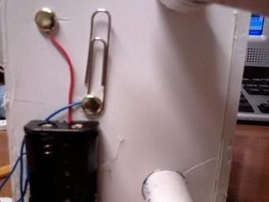

Wrap-up
End the lesson with some final discussions about what students designed/discovered. Connect their activity back to the focus question/problem, real world examples, and STEM careers.

Also include notes about any special cleanup considerations

Lesson Background for Teachers

Suggested Real-World STEM Connections
- List possible related Role Models in STEM (with details and links to more reading). Give suggestions for examples of scientists/engineers who are from underrepresented groups in STEM in related careers.
- List related real-world engineering problems and examples

Lesson Variations and Options
Include descriptions of alternative methods or ways to present things.

Explanation
Describe the background concepts and explanations behind the lesson. This can be more in depth than a teacher/instructor would actually share with students.

Key Concepts and Vocabulary
- Primary – Magnification
- Secondary – Structures
- Tertiary – Light

Safety Notes
- Safety instruction

